**Creating an AKO Test**

1. Login into power school and launch Performance Matters
2. Click on Tests 
3. Click on New Test 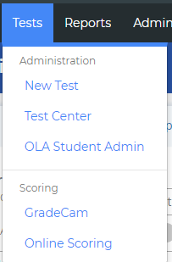
4. Click on Answer Key Only  Click Reload 
5. Select Answer Set and number of questions 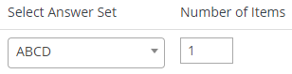 Click okay
6. Fill out Properties
   1. Assessment Title: Make it meaningful since it shows up on the scan sheet.
   2. Description is optional
   3. Category is required
   4. Course type is required
   5. Grade level choose all that show up.
   6. Chose one or make a new one based on your needs.
7. Fill out Administration
   1. Must have a testing window. Do not delete window.
   2. OLA is for online testing
   3. Scan sheets choose performance matters or GradeCam
      1. GradeCam has 40 question limitation
   4. Enter/Edit responses – allows you to modify the answer in the student item analysis report
   5. Limit Test Center – not being used.
   6. Reporting Options – not being used
   7. Audit – not being used
8. 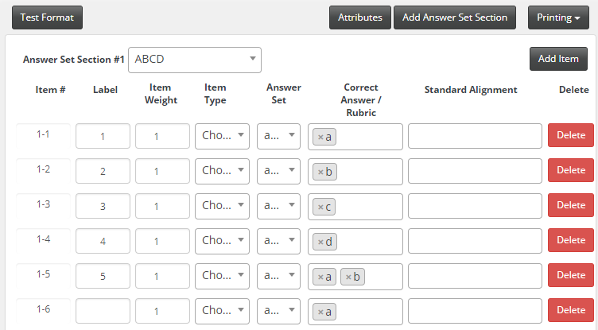
9. Click Save and click test preview to see the bubble sheet. 

**Printing bubble sheet**

1. Login to power school and launch Performance Matters
2. Click on “Tests” 
3. Click on “Test Center” 
4. Click on “Select” -> “Release: Online/ Paper Based” 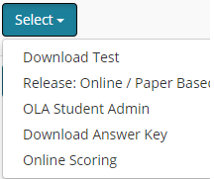
5. Choose your class in the drop down 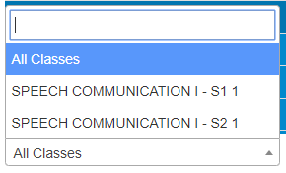
6. Click on “Preslugged Sheets” 
7. Click on PDF -> and send to a printer.

**Logging into Performance Matters**

1. Click Quick Links
2. Click on Power Teacher Portal Home
3. Click on box with arrow coming out
4. Click on Performance Matters

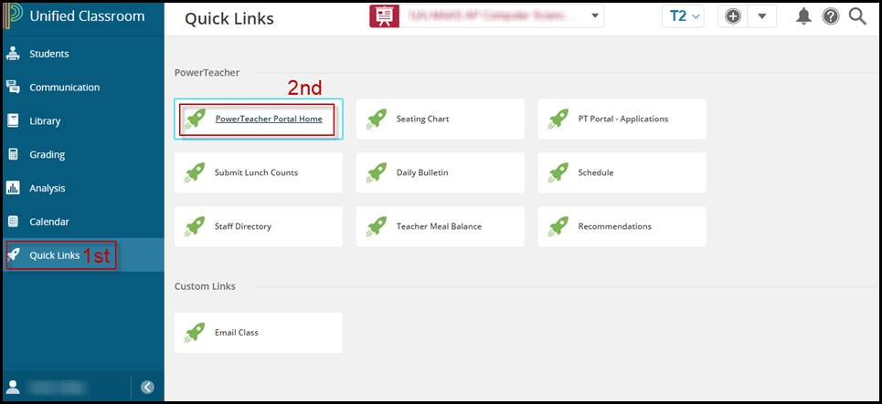

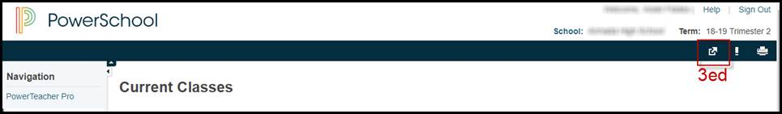 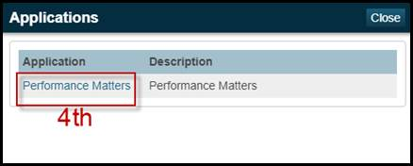

**3rd**

**Scanning Performance Matters bubble sheet**

1. Log into copy machine
2. Click on Scanner
3. Click send to Performance Matters. You will receive confirmation in your e-mail.

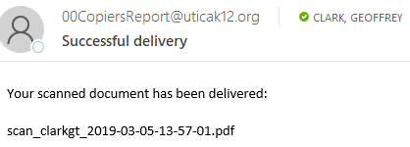

1. Login to Performance Matters click on Scanview: Click waffle next to MI_Utica 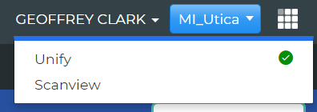
2. View for errors and correct in Scanview

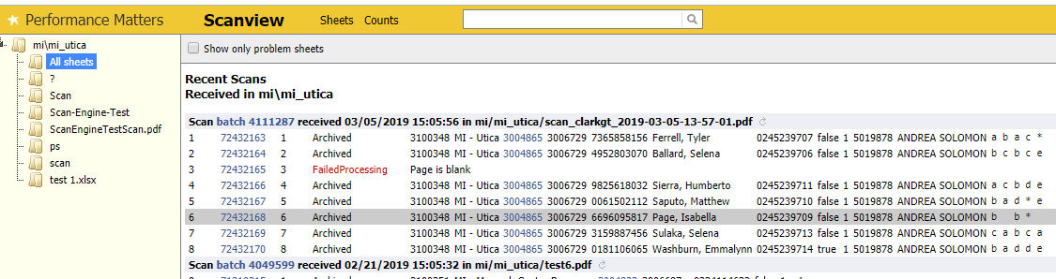

1. Answers can be changed in Scanview if choice was scanned incorrectly or fix it in the Student Item Analysis report. Here is a picture of how you can change the answer in Scanview.

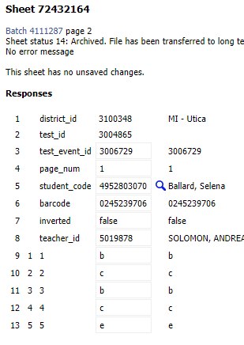

**Scanning GradeCam bubble sheet**

1. Log into Performance Matters
2. Click Test
3. Click GradeCam under Scoring
4. Change the number of questions in the box to match the test 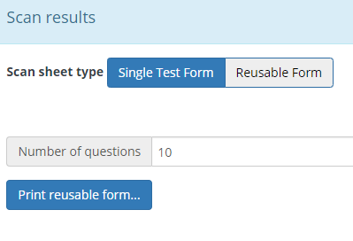
5. Scan test using webcam
   1. Can be done with phone if using browser
      1. Iphone suggested using safari
      2. Android suggested using firefox
   2. Document camera
   3. Laptop with integrated web camera
6. If choice was scanned incorrectly it will need to be fixed in the Student Item Analysis report.

**Sending Grade to Power School Grade book**

**Notes: You must use Additional Filters to limit your student population to a single class before attempting to Submit results to the Gradebook. You can only Submit student scores for one class section at a time.**

1. Click on Reports  then click on Student Item Analysis 
2. Select your test or the district test in the test title box 
   1. If your test doesn’t show up in the list, it is because it hasn’t been processed yet. Performance Matters updates their reports every 15 minutes (15, 30, 45, 00).
3. Review your students scores before pressing the “gradebook” button.
4. If you need to fix any students responses this is the report that will allow you to fix it, if enabled.
5. Filter to the class you want to send to the grade book. You need to do this for each hour if you teach the same class for multiple hours.
   1. Near the top left corner click on additional filters 
   2. Click on add student filter , a new window pops up.
   3. Click on the  tab
   4. Click on Course Subject, (this lists all the courses your students are in).
   5. Search for your course 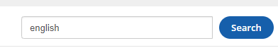and then select the course you teach. For example: English 10.
   6. Click on Class, and you will see all the English 10 classes. Select the correct semester class and hour. For example: 
   7. Click . Now you are ready to send grades to the gradebook for 2nd hour English 10.
6. When you are ready to send the score to the grade book press “gradebook” 
7. The following window pops up:

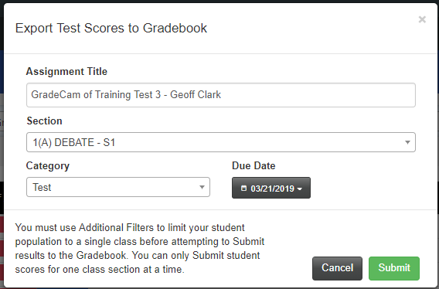

**D**

**C**

**B**

**A**

1. Change the name to what you want in the grade book
2. Make sure to select the correct section. If you don’t you will get an error
3. Choose the correct Category
4. Select the correct Due Date. The due date will put the score in the correct term i.e. Q3, Q4 or E2.